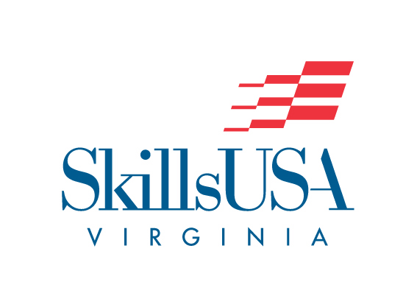

Promotional Flyer

Purpose
To design a promotional flyer that will encourage membership in SkillsUSA

Clothing Requirement
This contest does not require an interview; therefore, there are no special clothing requirements. However, contestants should be dressed in SkillsUSA attire or business dress for the awards ceremony.

Eligibility
This contest is open to all active SkillsUSA members.

DEADLINE
The contestant shall submit Promotional Flyer, verification form and the Pre-Judged Entry Form to the address announced by the SkillsUSA Virginia State Advisor. The entry must be postmarked by March 3, 2025

Exhibit of Entries
Observers will not be present during the judging. Promotional flyers may be viewed on the day of the skill competitions.

Pickup of Entries
Promotional Flyer entries must be picked up by 2 p.m. on the Saturday of the SLC.

Equipment and Materials
1. Supplied by SkillsUSA Virginia:
a. Tables, as needed
d. Three judges
2. Supplied by the contestant:
a. Promotional flyer
b. One-page, typewritten résumé
c. Verification form and Pre-judged entry form

Scope of the Contest
1. The theme for the flyer will be the current National SkillsUSA theme and must be stated on the flyer. To verify the national theme, go to http://www.skillsusa.org/about/theme/.
2. The flyer will be designed and constructed by one SkillsUSA member only.
3. Entries will be constructed on one 8 1/2" x 11" sheet of paper.
4. Entries will be mounted on an 11" x 14" white mounting board.
5. Design shall be created using any digital-design/imaging program (i.e., MS Photoshop, Publisher, PageMaker, InDesign, Photo Draw, Illustrator, Freehand, or similar software).
6. A Verification Form stating that the promotional flyer was the original, creative work of the contestant must be submitted. The form is to be signed by the student, SkillsUSA advisor, and school administrator and placed in a plain envelope on the back of the promotional flyer mounting board.
7. Copyright laws must be followed in the design. Do not use other artwork/photos without permission.
8. For SkillsUSA logos and guidelines, go to http://skillsusa.org/about/history-brand-resources/logos-and-graphic-standards/.
a. Do not add a space when spelling out "SkillsUSA" in text. "Skills USA" (with a space separating two words) is incorrect.
b. Do not alter or attempt to re-create any part of the art.
c. Do not use the phrase “No Limits” by itself (without SkillsUSA), in text or graphically.
9. The promotional flyer should possess educational information value, meaning the design relates to education

